PROJECT REPORT

**ESTIMATION OF BUSINESS EXPENSES**

**TEAM DETAILS:**

**TEAM LEADER : R.P.SARANYA**

**TEAM MEMBERS :A.MARIYAMBEE,K.YAZHINI,A.KOWSALYA**

**1.INTRODUCTION:**

**1.1OVERVIEW:**

**First I created an EMPATHY MAP . A map has four quardrants –says,thinks,Does and Feels.next .How do I Prepare for business management?How do you measure the business management success?.What are the critical issues that a businessman scorecard should measure?These are all things I shown in my four quardrants.Next I created BRAIN STORM.My team members give some idea for this brainstom,then I created my Data analysis,Dashboard and Story. Next I published my Dashboard and story in the Tableau Public**.

**1.2 PURPOSE:**

**The purpose of business estimation is important because they allow business to set expectations for their customers.They also help businesses to determine whether or not a project is feasible and how much profit they can expext to make.Estimating also allow businesses to plan for unforeseen expenses and keep track of pending.**

**2.PROBLEM DEFINITION AND DESIGN THINKING:**

**2.1 EMPATHY MAP:**

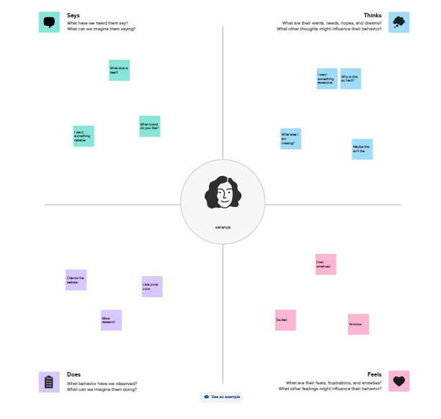

**2.2 IDEATION AND BRAINSTORMING MAP:**

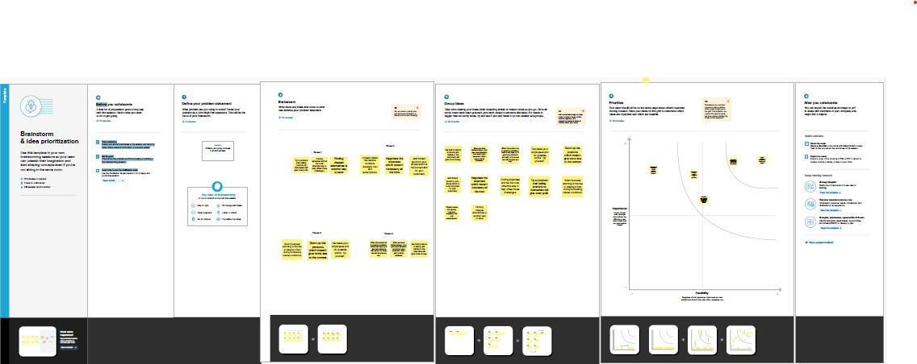

**3.RESULT:**

**DASHBOARD:**

**Dashboard 1: 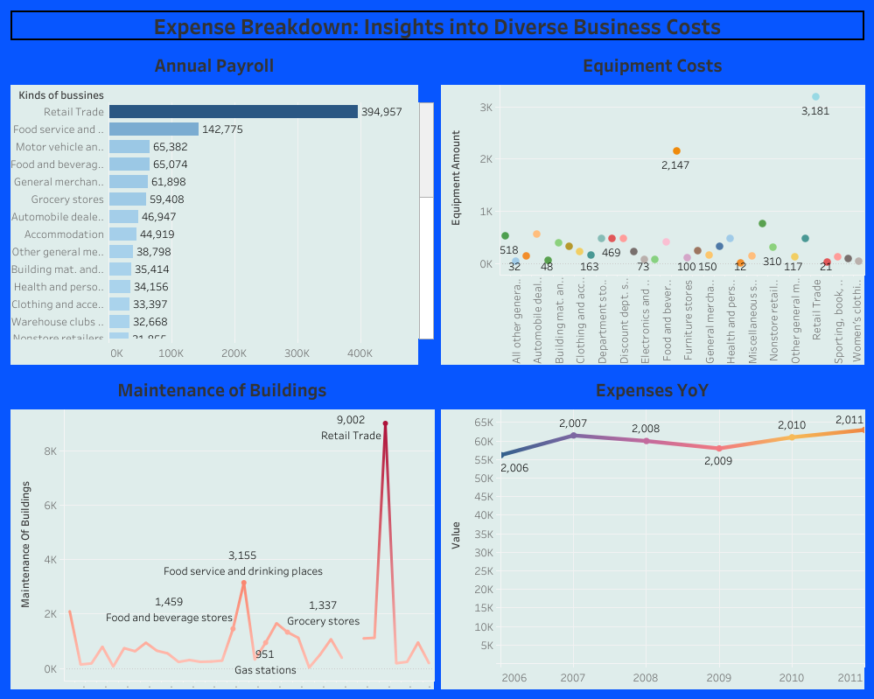Dashboard 2:** 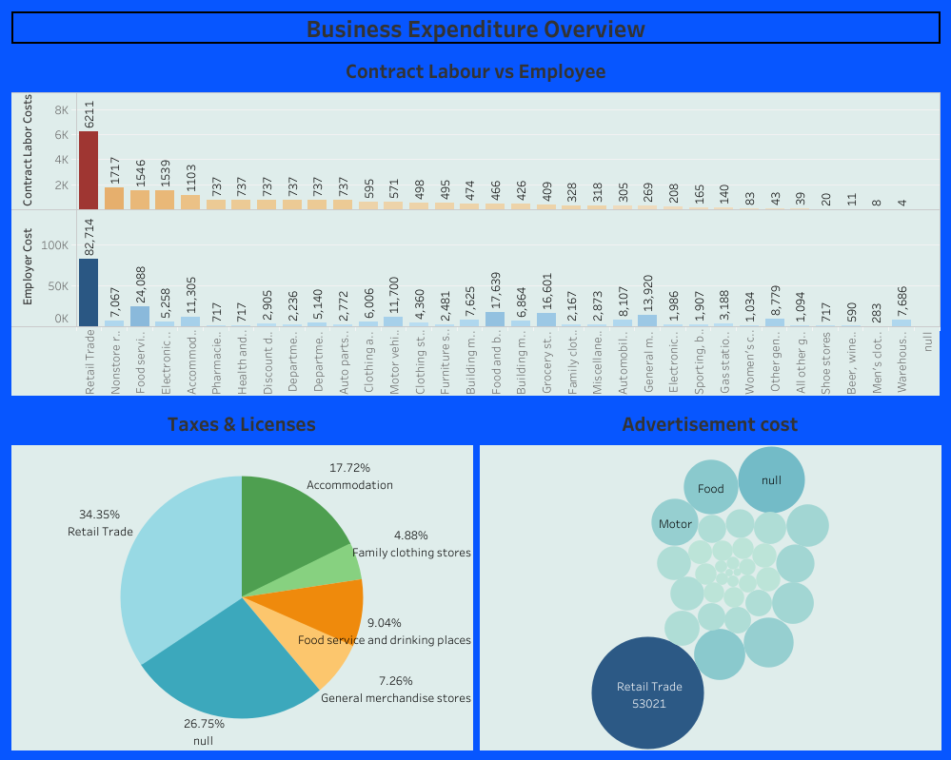

**Dashboard 3:**

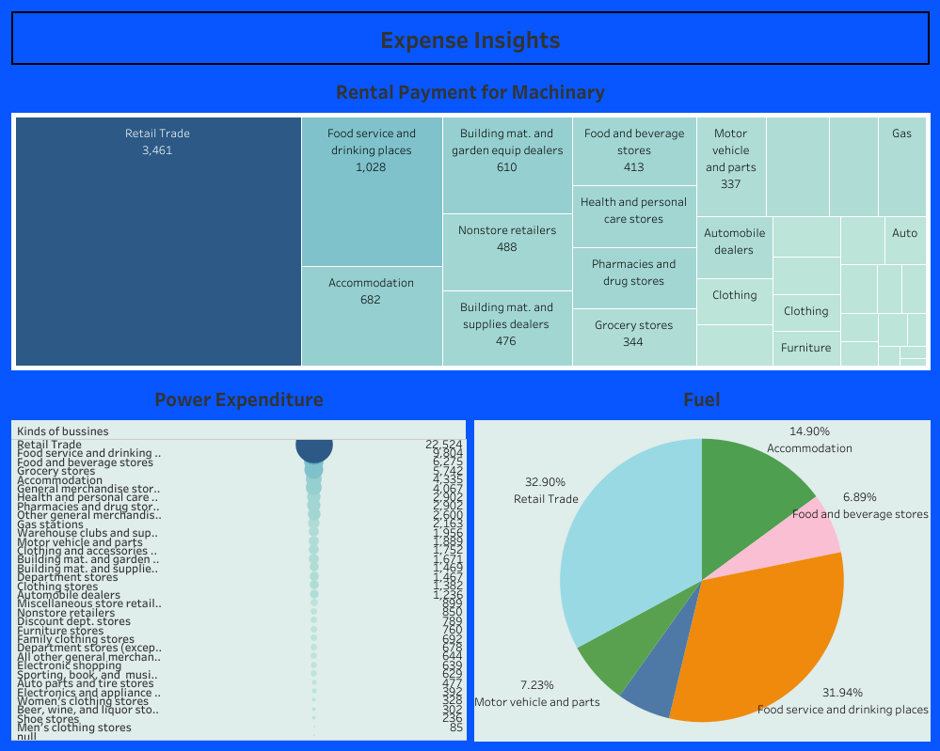

**STORY: ANNUAL PAYROLL:**

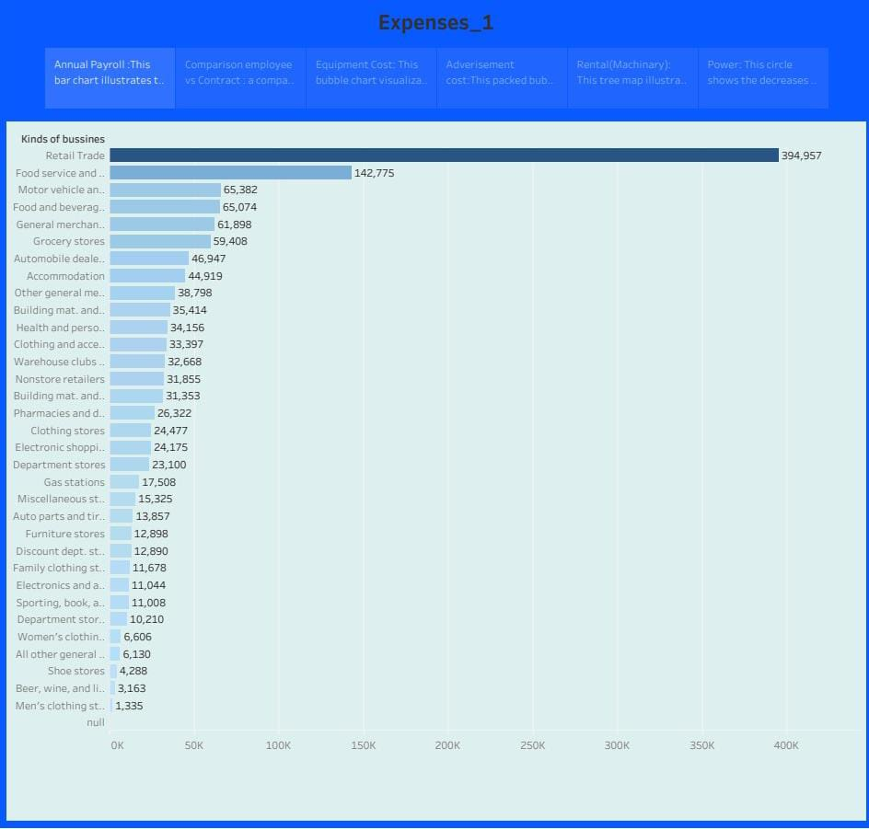

**CONTRACT LABOUR WITH EMPLOYEE: 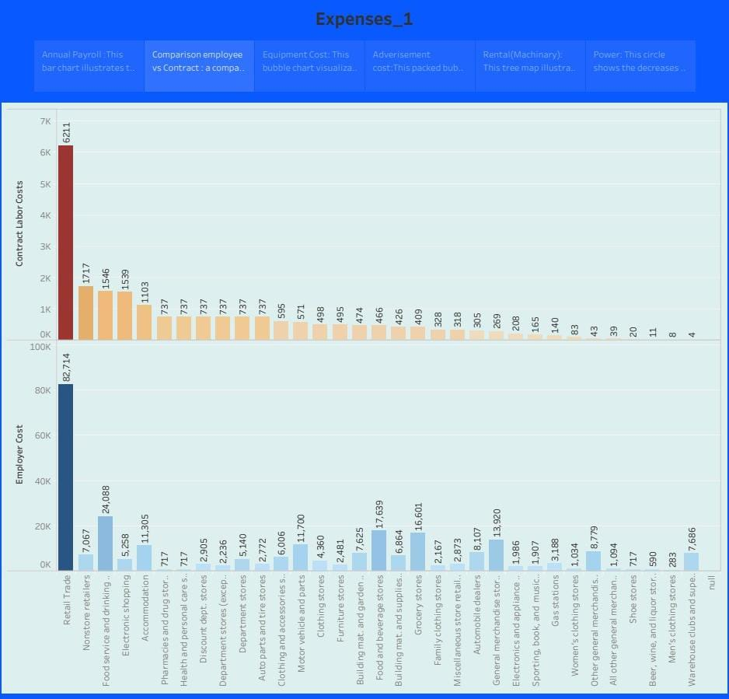 EQIPMENT COSTS:** 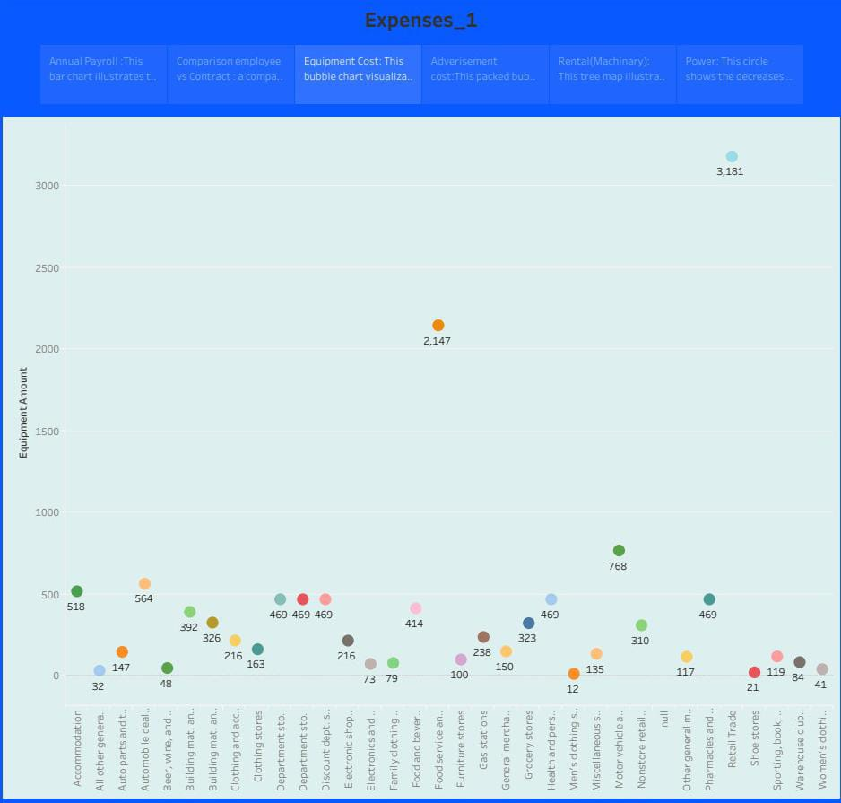

**ADVERTISEMENT COSTS:**

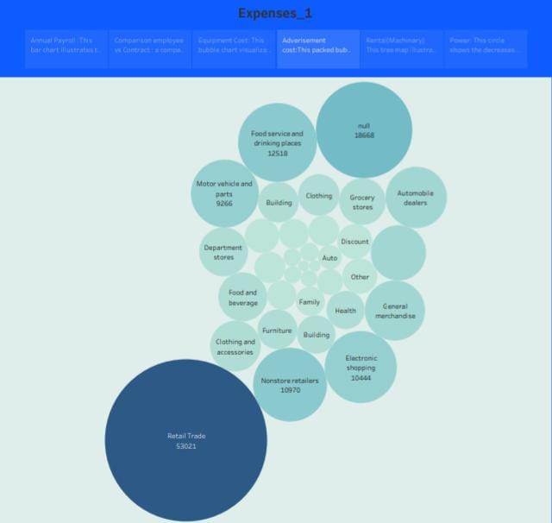

**RENTAL PAYMENT FOR MACHINERY:**

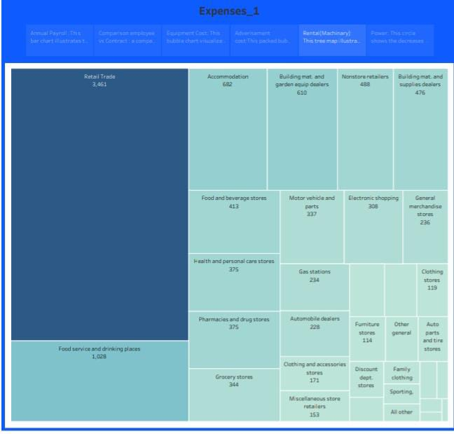

**POWER EXPENDITURE:**

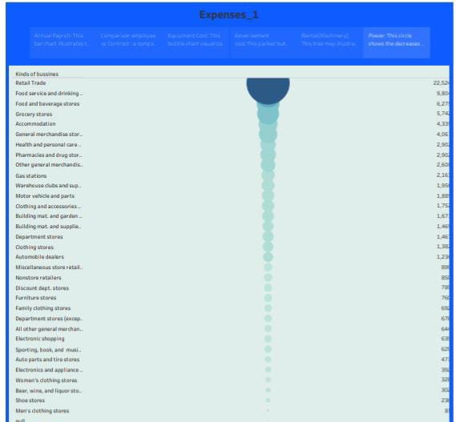

**TRANSPORTATION :** 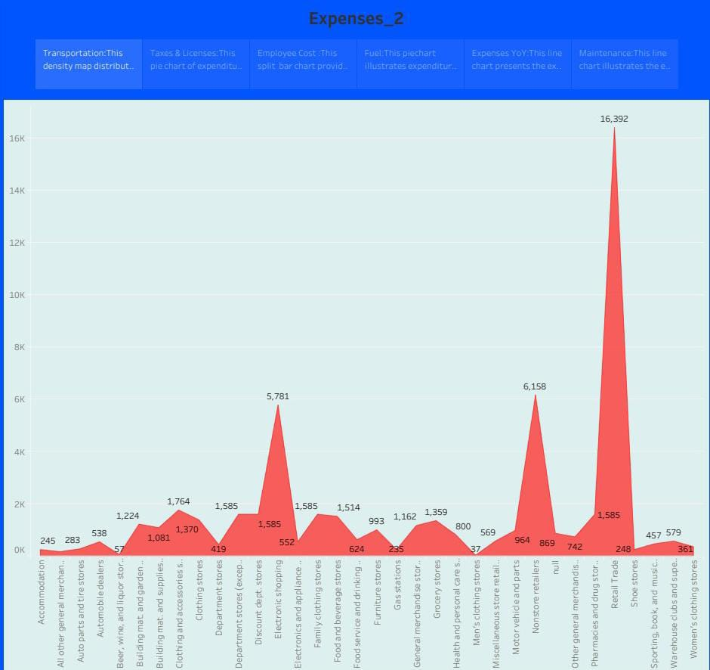

**TAXES AND LICENSES:** 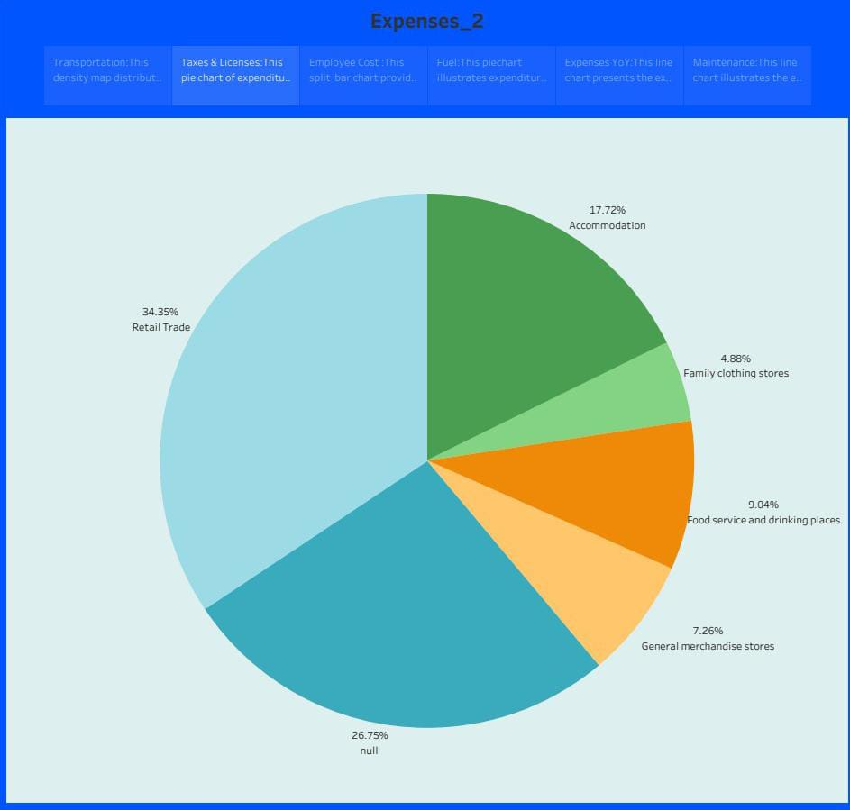

**EQUIPMENT COSTS:**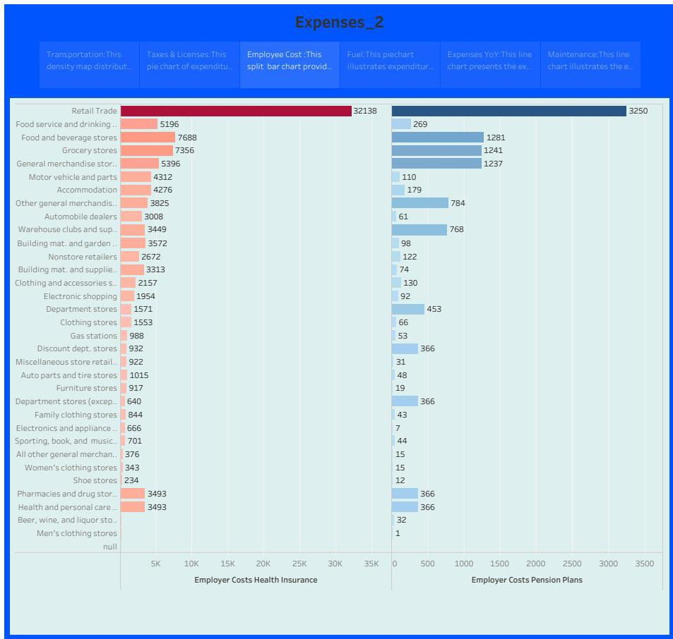

**FUEL:**

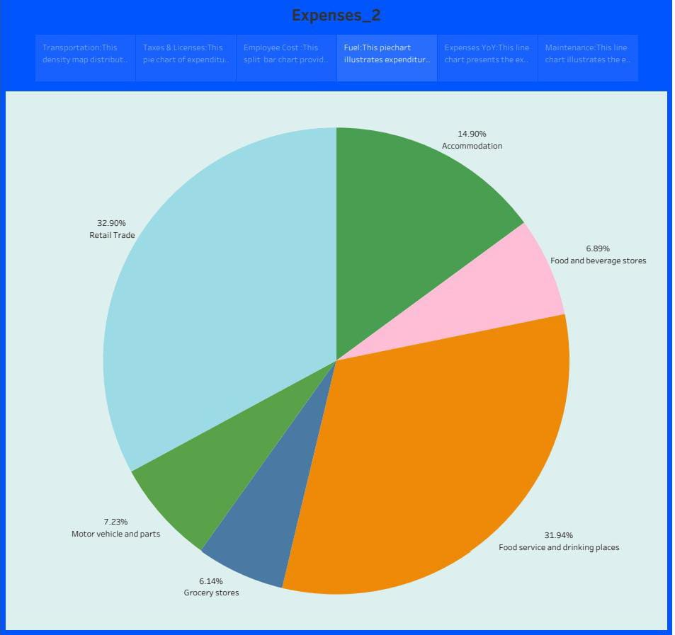

**EXPENSES YoY:**

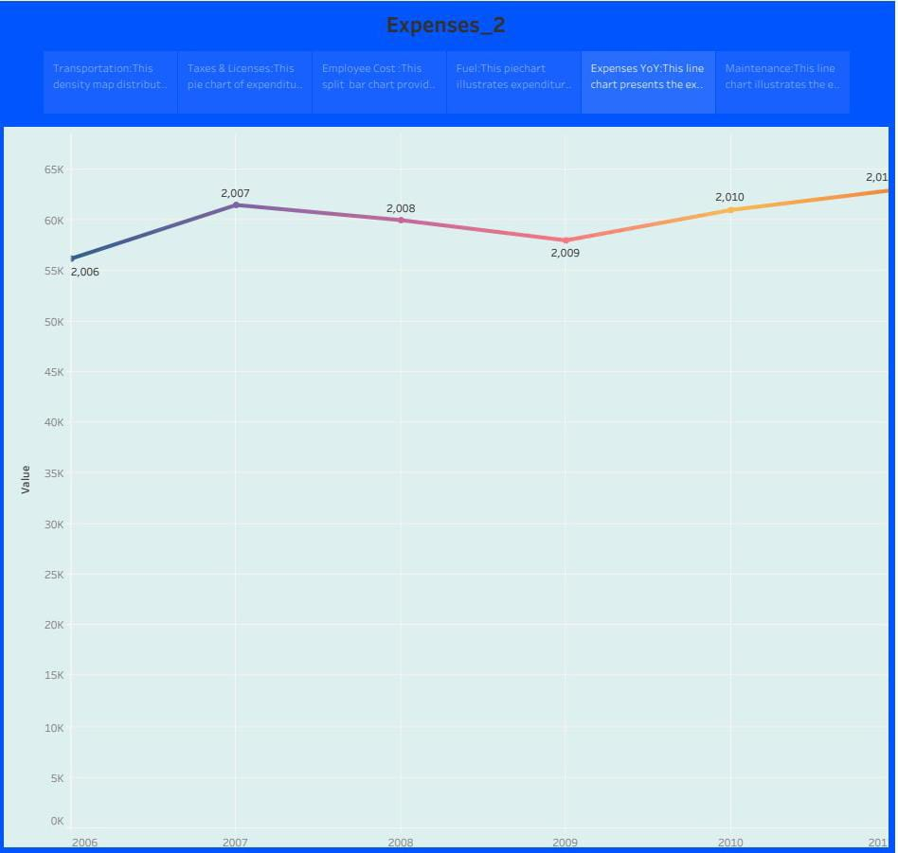

**MAINTENANCE OF BUILDINGS:**

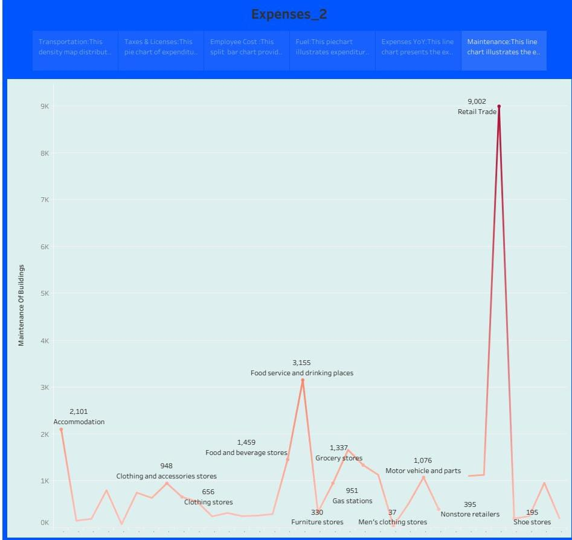

**4.ADVANTAGES AND DISADVANTAGES:**

**Advantages:**

* **Assistants to the management.**
* **Helps in reducing costs.**
* **Helps in forecasting.**
* **Helps in preparation of financial accounts.**
* **Helps the Government in determining loss of profit.**

**Disadvantages:**

* **Only past performance can be recorded.**
* **Costs keep on change in every year.**
* **Proper maintenance is required.**
* **Expertise is required to record.**
* **Complex system.**
* **Costly to maintain.**

**5.APPLICATIONS:**

**Operational costs: These are expenses directly related to the day-to-day operations of your business. They may include raw materials or supplies,packaging,shipping or delivecosts,maintenance and repairs, and any other expenses specific to your industry.**

**6.CONCLUSION:**

* **Project costs are being poorly estimated.**
* **The accuracy of cost estimation has to be improved**
* **Data collection.**
* **Use of tools.**

**7.FUTURE SCOPE:**

* **Investment decision.**
* **Work capital decision.**
* **Dividend decision.**
* **Profit Management.**